**The Pyramid**

**(#7)**

**Project Assignment 2 – ETL into DSS & Info for decision making**

**(ITRW 321)**

**Group Members:**

**Group Leader: [27008592 – Jeandre Pretorius]**

**[27694569 – Koos Kruger]**

**[26987899 – Juane Terblanche]**

**[29685532 Carlo – Greyling]**

**[27143929 – Keanu Jooste]**

**[27172945 – Eduan Naude]**

**Submission date: 10/14/2019**

Table of Contents

1 Description of group / database domain 1

2 ER diagram 1

3 Information needed for business decisions 2

4 Star schemas 2

5 Create DSS tables 3

6 ETL - Extract & Transform 3

7 ETL - Loading 3

8 Update / Refresh 3

9 SQL queries - information for decision making 3

# Description of group / database domain

We are a Loan Shark Company with a list of hitmen as assurance debts are repaid. We keep track of all hitmen in our service, information on clients that makes loans with our business, various loan options that clients can choose from, and a history of client payments and debts.

# ER diagram

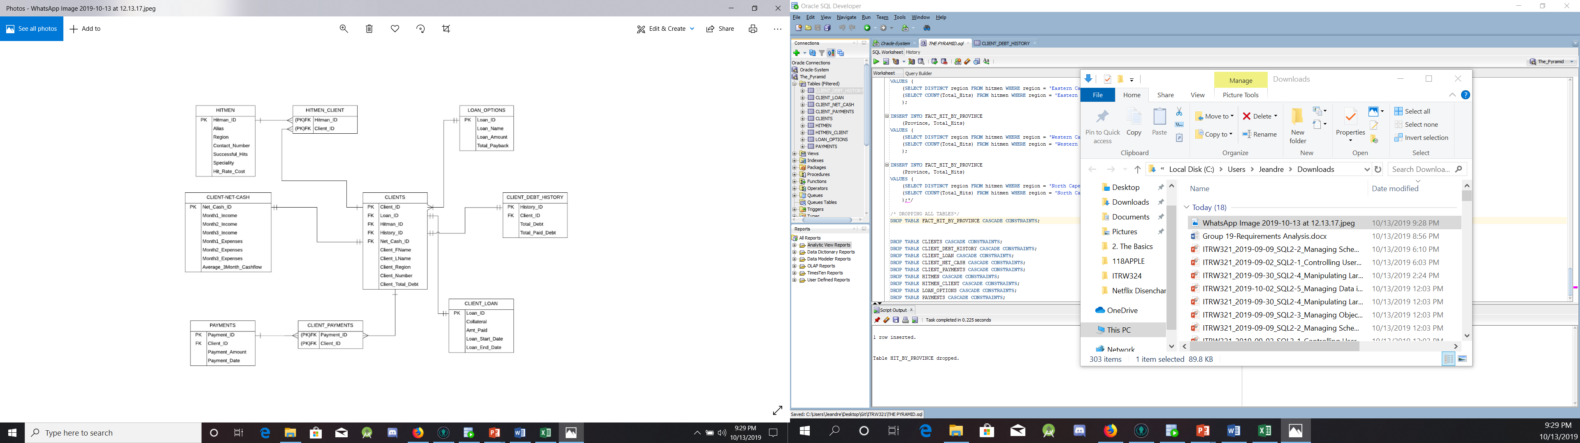

# Information needed for business decisions

Data from the tables will be summarized to help make important business decisions like:

* Where do we need to hire more hitmen?
* How much money has been made by region between specific dates?
* Summarized history of loans in every region.

# Star schemas

**FACT_HIT_BY_PROVINCE**

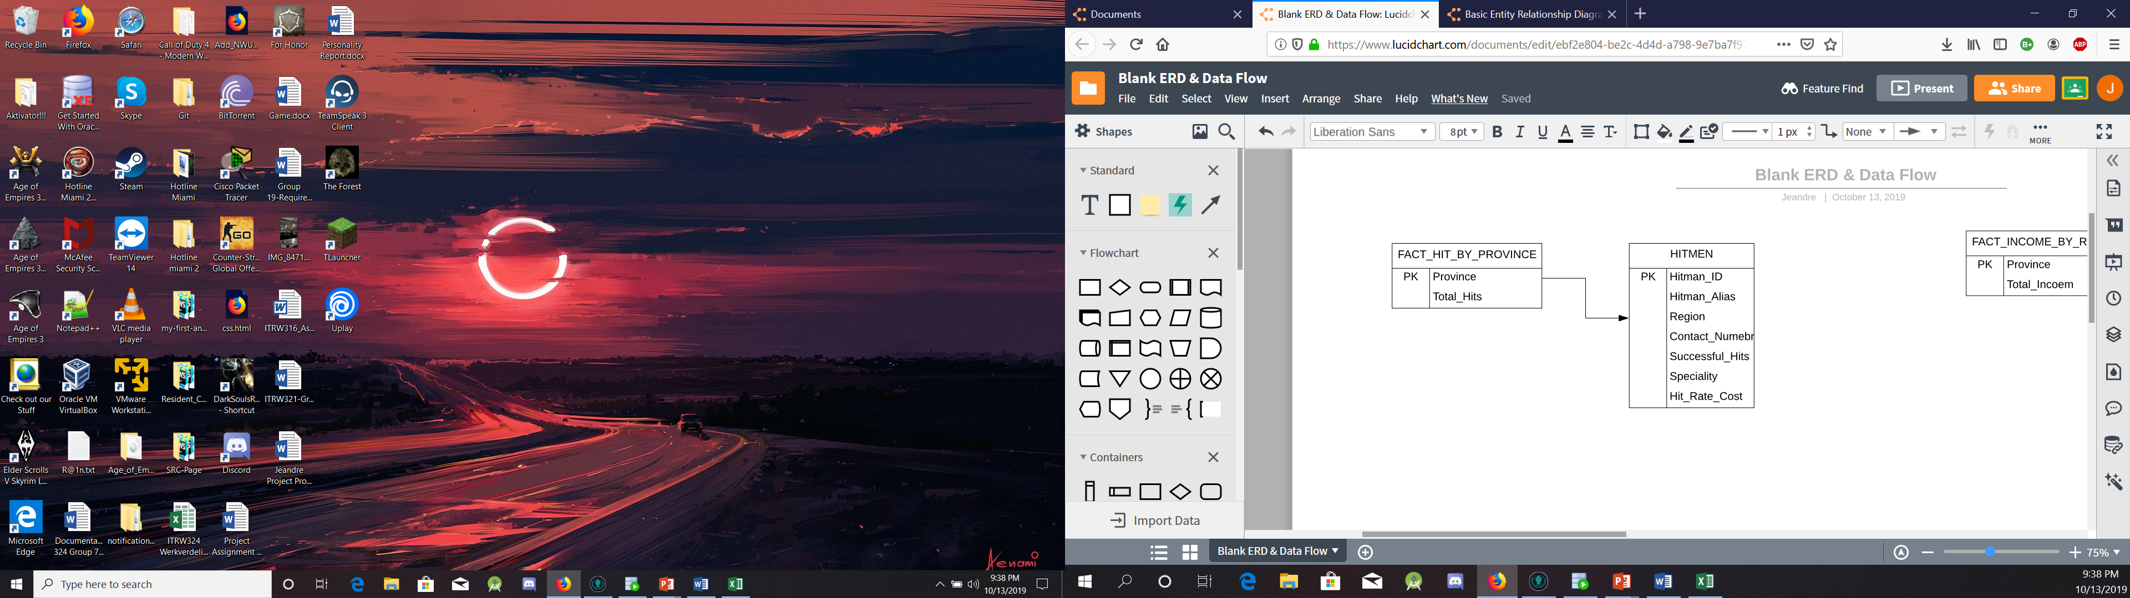

**FACT_INCOME_BY_REGION**

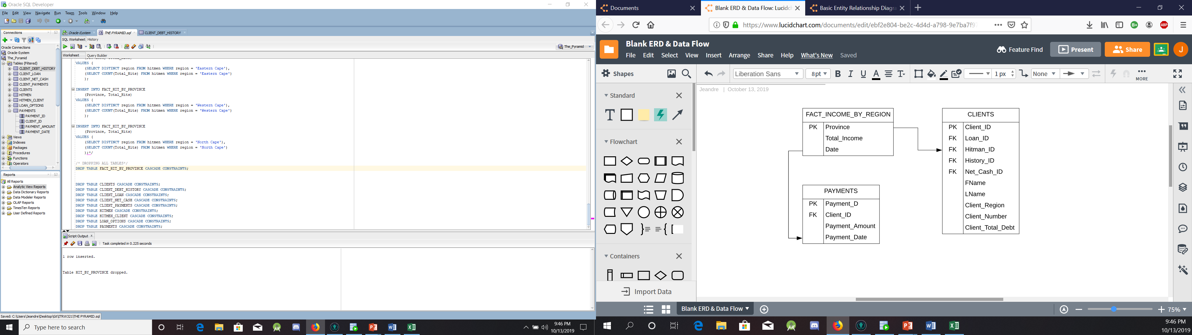

**FACT_LOAN_HISTORY**

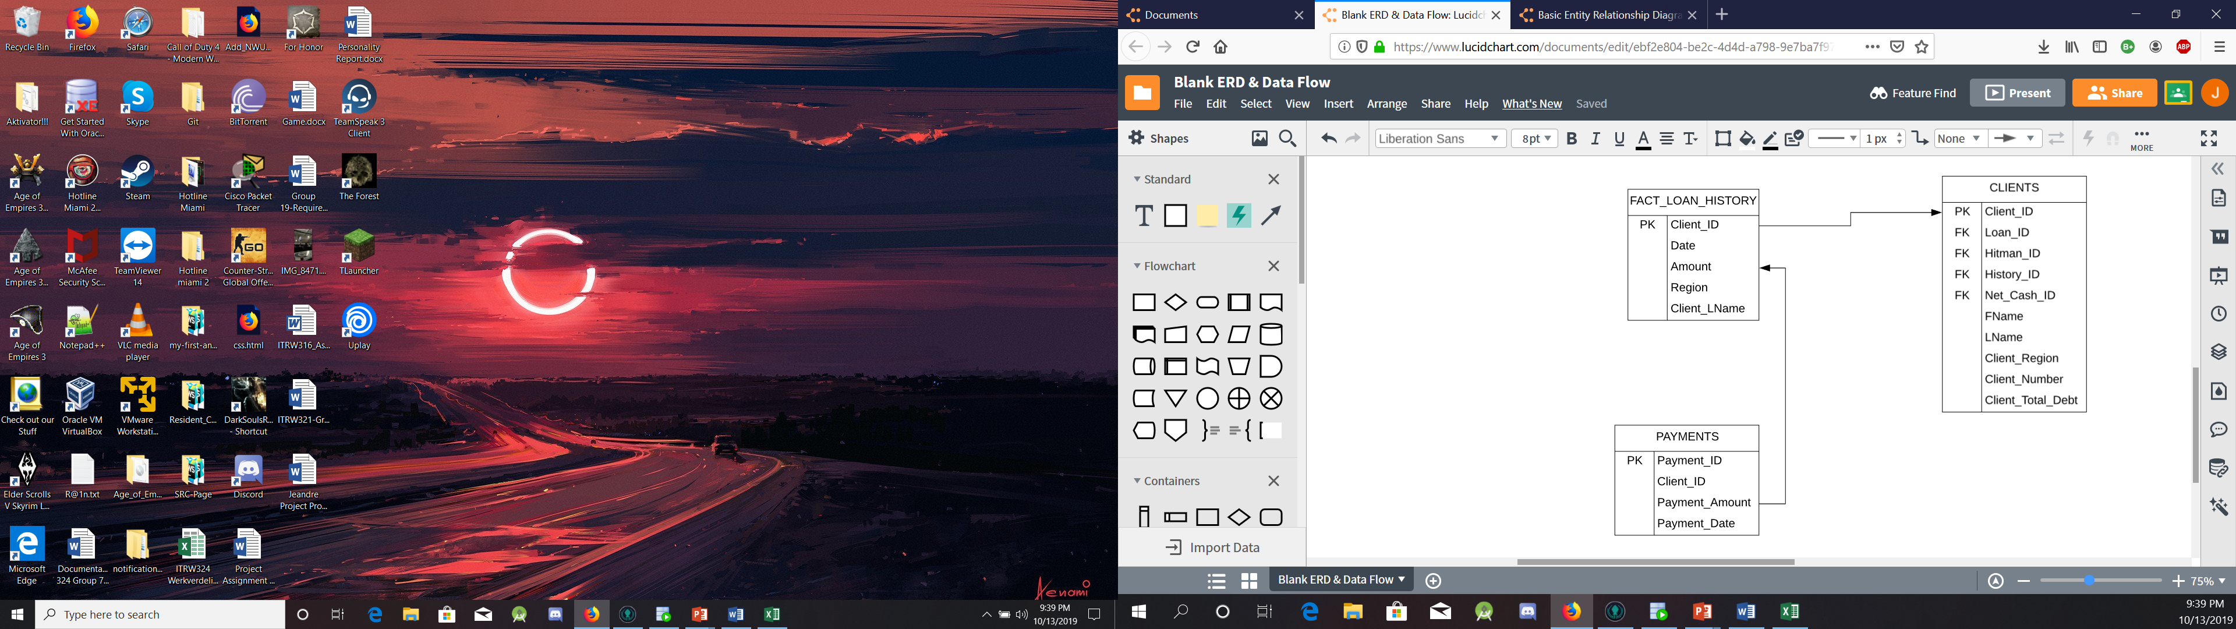

# Create DSS tables

SQL statements used to create DSS tables

# ETL - Extract & Transform

ETL process - SQL statements used to Extract from operational database, Transform and integrate

# ETL - Loading

ETL process - SQL statements used to Load the extracted data into your DSS tables

# Update / Refresh

SQL statements used to Update / Refresh DSS tables

# SQL queries - information for decision making

SQL queries to provide information for decision making.

Eg. Short description (1 liner) of information requirement for business decisions and SQL query to provide this information (may include sample output).